**Department of Computer Science and Engineering**

|  |  |
| --- | --- |
| **Course Code:CSE110** | **Credits: 1.5** |
| **Course Name: Programming Language 1** | **Semester: Sum’18** |

**Lab 02  
Introduction to DrJava**

1. **Topic Overview:**

In today’s lab, we will look at the basic building blocks of all computer programs – variables and literals. We will see the different data types available in java, and how to create variables and literals for each data type. We will conclude by writing a few simple programs using the java programming language.

1. **Lesson Fit:**

There is no pre-requisite to this lab.

1. **Learning Outcome:**

After this lecture, the students will be able to:

* 1. Work with DrJava to run Java codes
  2. Perform basic arithmetic operations
  3. Differentiate and find proper usage of various data types
  4. Get acquainted with Math library
  5. Print messages to the console of DrJava

1. **Anticipated Challenges and Possible Solutions**
   1. Teaching each part of the DrJava might feel overwhelming for the students since it’s a completely new thing they are being introduced to

**Solutions:**

* + 1. Go slow, step by step.
  1. Unable to differentiate between 1+2 and “1+2”

1. **Acceptance and Evaluation**

Students will show their progress as they complete each problem. They will be marked according to their class performance. Their maybe students who might not be able to finish all 13 tasks, they will submit them later and give a viva to get their performance mark.

1. **Activity Detail**
   1. **Hour: 1  
      Discussion: DrJava  
      Open Dr. Java:**

****On the Desktop, you should see an icon for DrJava (it looks like a big "J")

Double click on it. The main window of DrJava is broken up into three panes. On the left side, you should see a narrow pane containing the word "(Untitled)." This is shown in the screenshot below, circled in red.

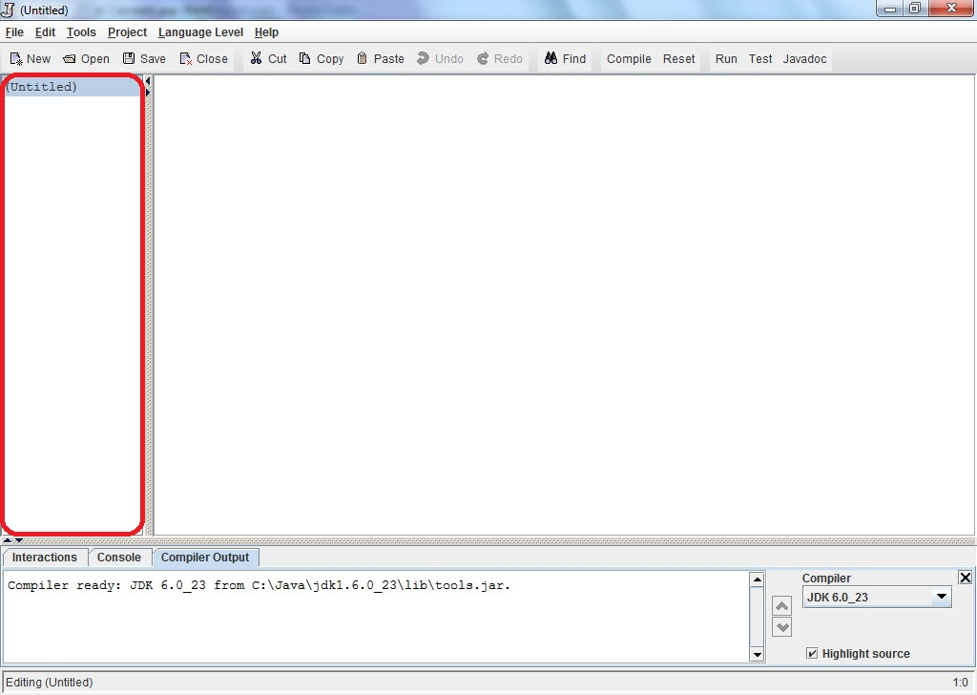

The large pane to the right of that is where you should type your program. At the bottom of the window is a pane with three tabs "Interactions", "Console", and "Compiler Output." These are shown in the image below, circled in red, black and blue respectively. Please check with the image and make sure you see these tabs on your Dr. Java window.

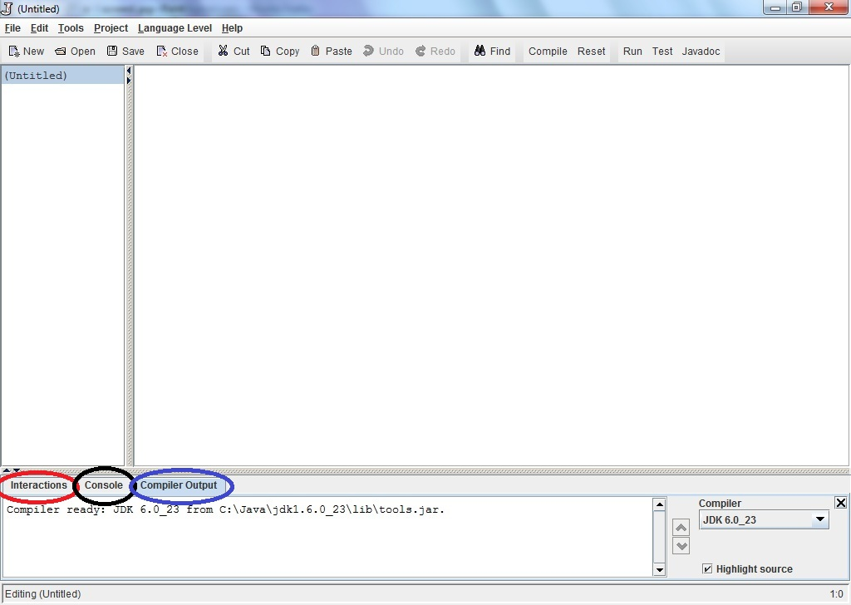

**Write Java statements in the Interactions pane: [21]**

Click on the "Interactions" tab in the bottom pane. This is a great feature of Dr. Java. Here, you can type any Java expression and Dr Java will instantaneously compile, interpret, and evaluate it. Try it by typing the following Java expressions. Type them in exactly as shown, including the quotation marks. Record the result of these interactions.

|  |  |
| --- | --- |
| 1. 3 2. 3+5 3. 4/6 4. 4.0/6 5. 4/6.0 6. 4.0/6.0 7. 9 - 4 * 3 8. (9 - 4) * 3 9. 3 /4 * 2 10. "hello" + "goodbye" 11. "3" + "5" 12. "3 + 5 is " + 3 + 5 13. "3 + 5 is " + (3 + 5) 14. 3 + 5 + “ is 3 + 5” | 1. (3 + 5) + “ is same as 3 + 5” 2. Math.pow(2,3) 3. Math.pow(15, 0.5) 4. Math.sqrt(16) + 8.3 5. Math.pow(2,3) + Math.sqrt(64) 6. Math.pow(Math.pow(2,3),2) 7. Math.toRadians(3) 8. Math.sin(90) 9. Now, based on your current knowledge, experiment and find out how to calculate the value of sin 90 degree. Your answer should be 1.0 or very close. **Hint**: Combine u & v. |

You may be discouraged by Java's poor math skills in examples l and m. In fact, the "+" operator does different things depending on its arguments. If both arguments are numbers, it adds them; if either argument is a String of characters, it concatenates them into a single String. **We will talk more about this in lecture later**. In the Interactions pane, you can also type more complex Java statements. For instance, to write "Hello World" to the console, we can use the println method. Type the following in the **Interactions** pane:

System.out.println("Hello World");

Now print your name to the console. Click on the Console tab and you should see:

Hello World

For most of the programs that you write in this class, the output of your program will be a series of statements printed to the console.

Try to print your name following the previous method.

* 1. **Hour: 2**

**Discussion: Code Practice**





* 1. **Hour: 3**

**Discussion: Reading Documents and Necessary Resources**